**Game Design Studio Two**

**“Mowdown”**

**Team Four**

Report for Sprint Two

24 / AUG / 2015 – 06 / SEP / 2015

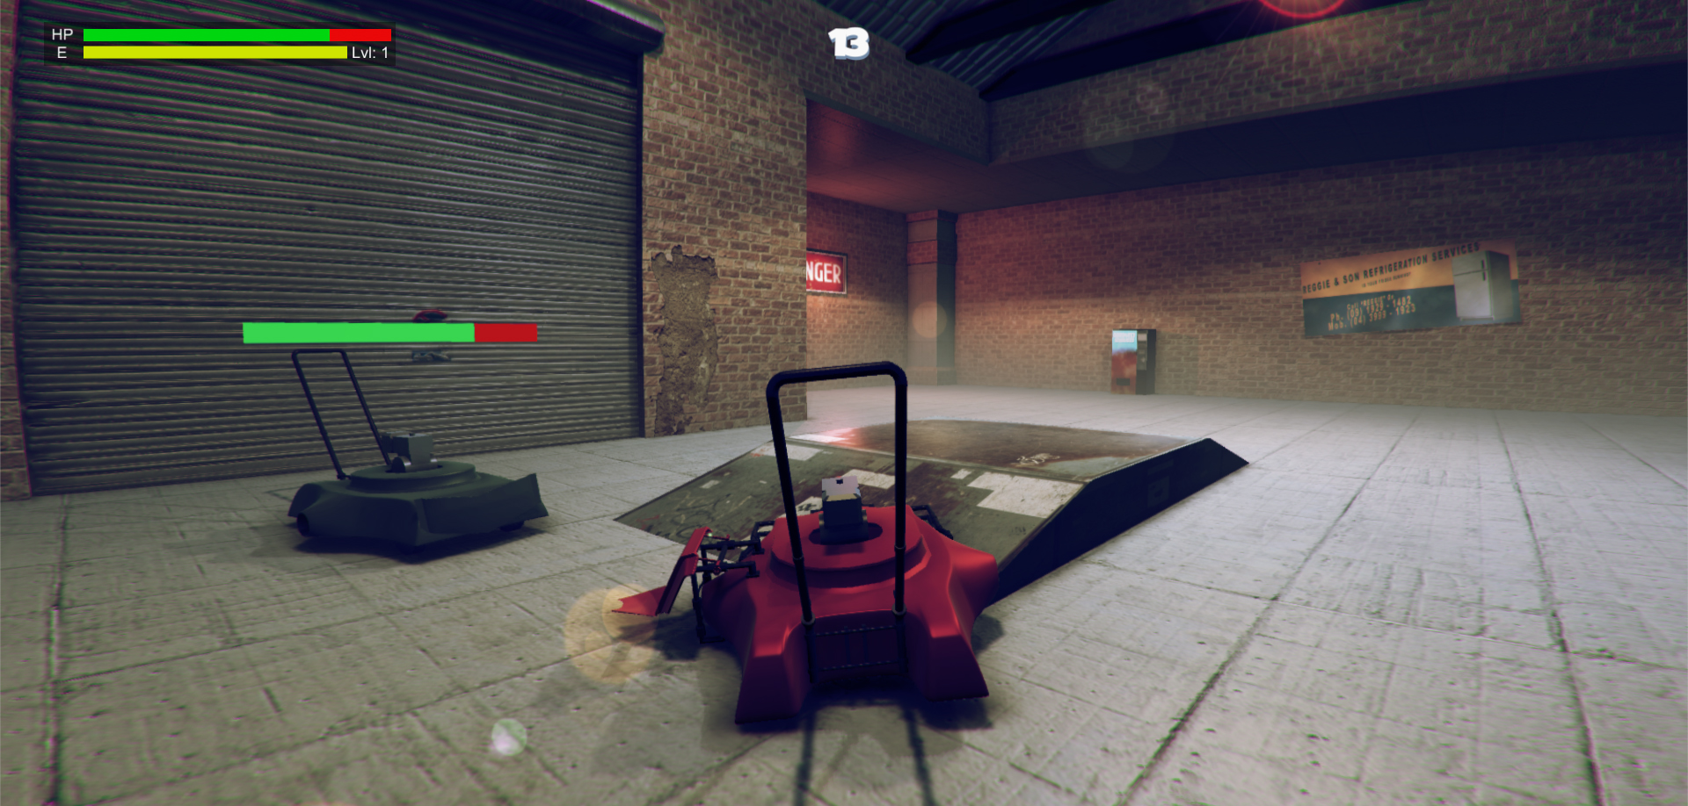

**Team Members:**

Matthew Carver –12028130

The most honoured Master of the Scrum,SirDeinyon Davies – 11688025

Robert McClelland –11743693

Dinh Bao Anh (Brendan) Vo – 11437237

Jesse Walker – 11729631

**OVERVIEW**

*Mowdown* is a ‘Demolition Derby’ or ‘Battle Bots’ style videogame, created by (in ascending alphanumeric order) Matthew Carver, Deinyon Davies, Robert McClelland, Dinh Bao Ahn (Brendan) Vo, and Jesse Walker.

Players customize one of several domestic **lawnmowers** by means of attaching defence appliances and weapons that have been unlocked and purchased by the player by means of in-game experience points and currency. Players compete against at least one autonomous opponent – a strategically formed battle-mower – as if both are controlled via Remote Control (R.C.).

Sprint Two sports several new features, bug fixes and enhancements, including (but not limited to): an enhanced menu User Interface, minimap prototype, framebuffer fragment shader effects (Ambient Occlusion, colour correction, etc), game analytics, a new level design, improved damage mechanics, attachments including a shield and a flipper, an obstacle-avoidance camera, attachment socketing system, a new lawnmower design, a “strafe booster” mesh and somewhat improved Artificial Intelligence.

**SPRINT PLAN AND EXECUTION**

Sprint Two of Project Mowdown set out to implement fifteen discrete new features including (but not limited to): bug-fixes, level design, improved Artificial Intelligence, improved User Interface, Game Analytics, vehicle modelling and vehicle attachment modelling and implementation. These fifteen task items were identified in the initial Sprint Meeting.

As of the preliminary Sprint Meeting, the Sprint Log proposed a **total** **estimated** investment of **2,510 minutes** – 1,670 minutes greater than the estimated investment for Sprint One - with an estimated **median** task duration of **130 minutes**. Having completed the sprint backlog, it was discussed that the team had likely neglected several critical tasks, and as such, the backlog would soon be expanded. The sprint would optimistically be completed in 1,550 minutes.

During the execution of the scrum, 9 critical and prerequisite tasks became apparent, which were completed and appended to the Sprint Log when necessary. The auxiliary tasks assumed an additional estimated duration of 1,100 minutes, expanding the **total** **estimated** sprint workload to **3,660** **minutes** (61 hours).

At Sprint finalisation, the Sprint Log totalled 24 expected and unexpected tasks. The team observed a **total** **logged** **workload** of **1,745 minutes** (~29 hours). 6 tasks stood incomplete or uninitiated at the time of sprint closure.

**PLAYTEST NOTES**

Test 1 - 4 Conducted by Robert McClelland​ 2/09/2015

Commit Version: “Super Boring UI for Color Selection”

**Anthony Dam** (No Controller Available)

Gender: Male

Fav Game: Xcom

Fav Genre: Strategy

Demographic: Pc Gamer

**Observations:**

**Item Store**

* Tried to click below spike to ‘deselect’
* Found it odd to be clicking ‘images’ like the spike

**Battle Scene**

* Went to arrow keys first
* Won first try
* Managed to get stuck on the fridge/crates
* Tried to break the environment
* **BUG:** the lighting was weird and made the map super dark for some reason

**Comments:**

* Controls were too focused on the left hand

Suggested: Movement on arrow keys, Activateables on QWER like MOBAS

Suggested for Controller: A is front socket, Y is back socket (and left/right is normal)

* 2nd map is a bit small
* Hazards should only be ‘activated’ if they do dmg
* Boost/Strafe should require investment of attachment
* If environment is going to hurt make it obvious (Like spiky walls)
* Didn’t really notice the minimap

**Suggestions:**

* Flipping should do continuous hp dmg or have a counter till you lose/win
* Vertical/Horizontal Saws
* Early activateable traps can be a chair with a bucket of acid on it (knock over the chair to activate)
* Map can be upgradeable? Paper Outline -> Radar -> Top down camera
* Time Limit over just traditional timer

**Tiasha Lawson** (Controller available)

Gender: Female

Fav Game: Bioshock

Fav Genre: Indie

Demographic: No preference to platform/ play what’s available

**Observations:**

**Battle Scene**

* Flipped on 2nd try, easier on controller (Flip was mapped to X)
* Figured out controls fine on controller
* Focused on flipping cuz ramming hurts (could just be personal playstyle)
* Preferred bumper acceleration over trigger acceleration
* **BUG:** Bot got caught ‘wandering’ into the fence 50% of the time

**Comments:**

**Store Scene**

* ‘Ok’ button rather than click the mower
* ‘A’ button for controller
* Don’t make too many bits multi-color customizable – limit to just sockets, motor and body
* 4 socket points will provide enough customization

**Battle Scene**

* Battles are a bit short
* Map 2 is a bit small on the corners (no room to manoeuvre to get back behind enemy since both same speed)

**Suggestions:**

* Hazards should be activateable
* Environment hurts as an option
* Attachments result in activateables (boost/strafe tied to the rocket on the right socket)
* If more than one bot shows up then it should be FFA
* Drifting might be cool to solve the problem of the small 2nd map
* Quick-Spin attachment?
* Ranged weapons should be rly hard to aim if available (like green shell in Mario kart)

**Angus Munro (Controller Unavailable Controls Reassigned to movement with arrow keys)**

Gender: Male

Fav Game: Kerbal Space Program

Fav Genre: Simulation

Demographic: PC-casual

**Observations**

**Battle Scene**

* Won first by flipping
* Car controls are good (over direct WASD control)
* Controls are better with right hand on arrows, left hand is less busy
* Cover was too similar in color (changed to black in subsequent tests)
* Cover had too little hp
* The game is too easy (really simple to flip)
* AI wanders a bit too much
* Battles are a bit short

**Comments**

**Map 2**

* Motion blur is a bit much, lens flare is fine
* Map is a bit too small
* Map should be made bigger before making the turning circle smaller
* Preferred the first map mechanically preferred 2nd aesthetically

**Item Store**

* **BUG:** Spike did not fix to player rotation
* Color slider over picker
* Model should not always follow mouse
* Coloring different parts would be cool
* 4 is enough sockets

**Danielle Lyle-Stirling (Conducted with Angus Munro)**

Gender: Female

Fav Game: Fallout 3

Fav Genre: FP RPG

Demographic: PC but prefers controllers

**Comments**

**Battle Scene**

* Steering controls are good
* Controls are more natural with right on arrows left on activateables
* Flipping is more fun than ramming
* AI needs to know how to flip itself back over
* Countdown is good for flipping (over deprecating hp)
* Enemy bot is a bit too simple
* Map is too small/simple to require the mini-map

**Future (Combined with Future Suggestions from Angus)**

* Drifting should be an option not a constant thing (Wheel Attachment?)
* Ranged can exist but should be a high skill thing
* Attachments result in activateables (boost/strafeing not there from start)
* Fully restored attachments after battle (difficulty can increase cost)
* Hazards can be both static and activateable
* Some sort of plough so hitting from front results in enemy rolling over you
* Catapults/Oilslick attachment
* 4 player multiplayer max, FFA/2v2
* Map needs to be bigger than the first if playing multiplayer
* Split screen should be fine, horizontal split first
* Had fun

Test Conducted by Matthew Carver & Deinyon Davies 04 / 09 / 2015

Commit Version: “Implemented Wheel Model Display”

**Hollie Turnbull-Walsh** (Controller Unavailable)

Gender: Female

Favourite Game: Kingdome Hearts, Deamon Stone, Dragon Age, Shadows of the Damned

Favourite Genre: Comedy, RPG

Favourite Platform: PC & Console

**Comments:**

Very interesting idea. Fun from the start

make sure you have a select button for the mower cuz that wasn’t clear

Awesome graphics, fantastic animation.

map is kina closed of in the way that the building is there..because you require room to turn that sides of the building are a no go area

The game is good – had trouble with controls bur I couldn’t even do it when it was a remote control car in real life so it might just be me

Test Conducted by Matthew Carver & Deinyon Davies 04 / 09 / 2015

Commit Version: “Implemented Wheel Model Display”

**Daum Park** (Controller Unavailable)

Gender: Male

Favourite Game: CS: GO

Favourite Genre: Shooter

Favourite Platform: PC & Tabletop

**Comments:**

Great game, I like the concept and the customizable mowers.More feedback when objects collide it feels a bit bland when they hit.

Fix colour bug, and physics

Test Conducted by Matthew Carver & Deinyon Davies 04 / 09 / 2015

Commit Version: “Implemented Wheel Model Display”

**Yiannis Chambers** (Controller Unavailable)

Gender: Male

Favourite Game: Papers, Please; DEFCON; Red Orchestra; Balance of Power

Favourite Genre: Tactical shooter; governmental simulation.

Favourite Platform: PC

**Comments:**

Very interesting idea. Fun from the start

Decent interface – color slider menu does not work in first screen; good feedback on buttons in first screen, but weapon selection screen in second screen does not offer the user feedback when they hover over weapon (and weapon is off centre when you add it on screen).

Awesome graphics, fantastic animation.

Should be better feedback when collisions happen (explosions, the like) – but that’s just aesthetics!

The game is good – no problems with gameplay!

Test Conducted by Deinyon Davies 05 / 09 / 2015

Commit Version: “Implemented Wheel Model Display”

**Terece Mason** (Controller Unavailable)

Gender: Female

Favourite Game: The Sims 2

Favourite Genre: Simulation

Favourite Platform: PC & Wii

Demographic: Casual

**Observations:**

**Shop Scene (Menu)**

* Attempted to navigate mower selection menu using arrow keys.
* Attempted to deselect / detach the spike from the mower once it had been .attached. Detachment was not yet implemented.
* Enjoyed colour customization.
* Perturbed when colour was reset when round ended.
* Unsure of the purpose of the spike item, or the significance of it being attached.
* [BUG]: Spike attachment was misaligned
* [BUG]: Colour reset to black after having selected the desired mower.

**Battle Scene One (Farm)**

* Briefly confused when the battle began.
* Won the round several times with little effort, usually unexpectedly.
* Did not identify strategies for avoiding the opponent’s shield.
* Enjoyed flipping the opponent.

**Battle Scene Two (Garage / Warehouse)**

* Opponent would occasionally become stuck on the ramp.
* Player would occasionally become stuck on the ramp. Attempted to use flipper to encourage contact with wheels to the ground.
* [BUG]: Opponent mower induced several high-velocity forces on the player.

Test Conducted by Deinyon Davies 06 / 09 / 2015

Commit Version: “Fixed disappearing robot bug”

**Gareth Owen** (Controller Unavailable)

Gender: Male

Favourite Game: Pac-Man 20th Anniversary

Favourite Genre: Puzzle Platformers

Favourite Platform: PC

Demographic: Casual

**Observations:**

**Shop Scene (Menu)**

* Briefly confused about the purpose of the ‘mower selection’ User Interface. Did not notice the “Select Your Mower” title.
* Did not attempt to customize the mower (neither colour nor attachments).

**Battle Scene One (Farm)**

* Had difficulty operating the vehicle using the WASD controls. Would prefer optional use of Inverted-T arrow (cursor) keys.
* Won several rounds without significant attempt, often resulting in confusion.
* Player regularly opted to restart the battle scene via the IDE instead of navigating the ‘shop’ menu.
* Player became frustrated with collision-style attacks, and suggested that damage was not predictable.
* Enjoyed flipping the opponent

**SCRUM MEETING LOGS**

**24 / AUG / 2015**

4:30pm – 6:00pm

**Location**: UTS Building 11, Game Design Studio Laboratory

**Members present**: Brendan, Deinyon, Matthew, Robert

The team identified backlog items and discussed time estimates.

**31 / AUG / 2015**

4:30pm – 6:00pm

**Location**: UTS Building 11, Game Design Studio Laboratory

**Members present**: Brendan, Deinyon, Jesse, Matthew, Robert

The team discussed minimap implementation; considering Render Layers to create a ‘radar-like’ blip User Interface.

Discussed the size of the newly implemented Garage level design.

Discussed and proposed design and implementation for shield attachments.

**01 / SEP / 2015**

**Location**: Online Group Discussion

**Members present**: Deinyon, Jesse, Matthew, Robert

Discussed prototype mower design. See the following figure of the design prototype.

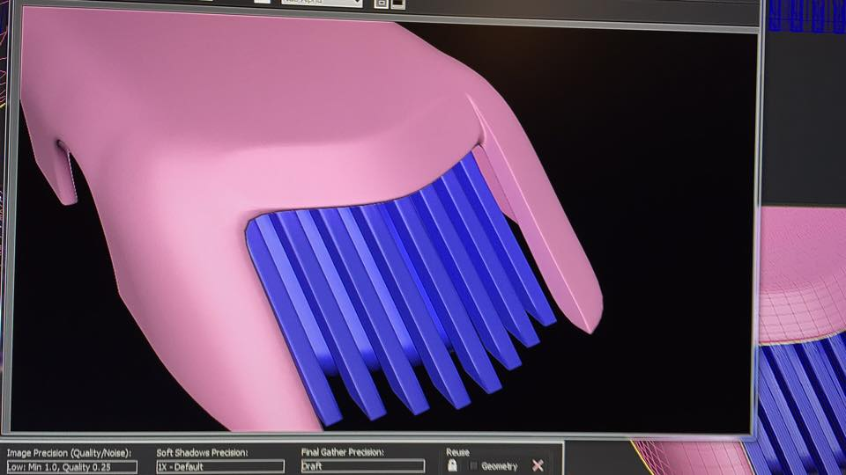

**02 / SEP / 2015**

**Location**: Online Group Discussion

**Members present**: Deinyon, Jesse, Matthew, Robert

Discussed methods of conveying programmatic attributes between scenes and prefabs.

Discussed a bug associated with ray projections to determine wheel model position.

Discussed AI bugs which would cause ‘sticking’ to obstacles and walls.

**BURNDOWN CHART**

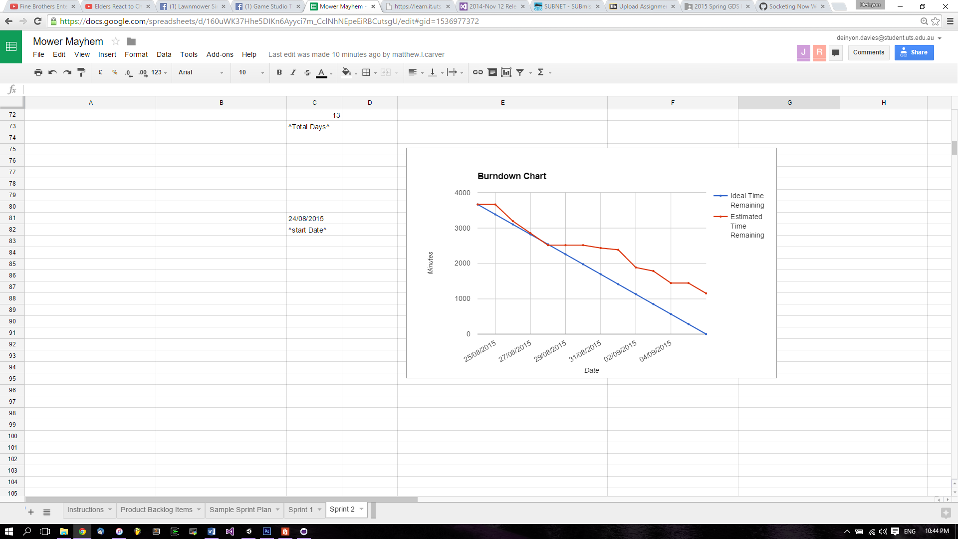

**REFLECTION**

Though Sprint Two yielded several important new features, enhancements and fixes, the substantial estimated commitment proposed by the team during the preliminary sprint meeting exceeded the time that the team could invest within the sprint time-box. Additionally, the project exhibited some ‘Scope Creep’ as new prerequisite tasks were found during development. The Burndown Chart illustrates that the team maintained the necessary workload for three to four days, until such a commitment was no longer possible. It will be important to realistically delegate tasks during planning for Sprint Three, with careful consideration to the necessary daily workload for each member in order to successfully execute the sprint.

**SPECIAL CIRCUMSTANCES**

N/A

**VERSION CONTROL COMMIT LOG**

commit a12b63df626fab68bd7616293d61678bd48d913d

Merge: af31af3 f910d45

Author: Deinyon Davies <deinyond@gmail.com>

Date: Sun Sep 6 22:24:22 2015 +1000

Merge branch 'master' of https://github.com/ddoodm/GameStudioTwo

commit af31af374be08e4082e10ab09228e3dd943d9e76

Author: Deinyon Davies <deinyond@gmail.com>

Date: Sun Sep 6 22:22:20 2015 +1000

Initial Commit of Sprint Two Documentation

commit f910d456a317f142d2da02f599625fae28abf725

Author: JesseWalker11729631 <11729631@student.uts.edu.au>

Date: Sun Sep 6 21:02:25 2015 +1000

Socketing Now Works in Garage

commit e0114cdd994d36a70993bec025cf24217799896e

Author: Deinyon Davies <deinyond@gmail.com>

Date: Sun Sep 6 19:29:34 2015 +1000

Fixed disappearing robot bug

commit c5fcf1b046d4fe65160ef786c528802ada75cccb

Author: JesseWalker11729631 <11729631@student.uts.edu.au>

Date: Sun Sep 6 16:56:49 2015 +1000

Can Spawn Handle On Back Socket

commit 8756fd26b75ddd2467ed2f0acb21410586a34b05

Merge: 8e7df5e 8c51625

Author: Deinyon Davies <deinyond@gmail.com>

Date: Sun Sep 6 11:54:15 2015 +1000

Merge branch 'master' of https://github.com/ddoodm/GameStudioTwo

commit 8e7df5e15c59789e42513f6dbf5393ef0c582bfb

Author: Deinyon Davies <deinyond@gmail.com>

Date: Sun Sep 6 11:52:28 2015 +1000

Fixed terrible AI bugs

commit 8c51625c2bdc875ddcc6d8061143d481b5522974

Author: JesseWalker11729631 <11729631@student.uts.edu.au>

Date: Sun Sep 6 02:12:01 2015 +1000

Sockets Added(No Functionality), Various Store UI Tweaks and Functionality Updates

commit c9b4cd320de5c332d91e3f572d39ed110a45adb4

Author: robafett <ram_95@msn.com>

Date: Fri Sep 4 22:42:12 2015 +1000

More tests

commit cc98b346a7032b772eaee8f9637a7d9a4a5e6806

Author: robafett <ram_95@msn.com>

Date: Thu Sep 3 18:48:51 2015 +1000

Fixed up controller support, added armor back onto bot doesn't look gr8 but works

commit e12ebb0fa1c15f36b37a1f436dcafd1ce4081ab2

Author: Matthew Carver <matthew_carver@live.com>

Date: Thu Sep 3 16:28:46 2015 +1000

Added the new mower and assets

Created subfolders to organise the models but didnt move them because I

am unsure if it will ruin any code you guys have

commit 10fcbd71ab3a8e4fce6fa645d35d93824de4835f

Author: Deinyon Davies <deinyond@gmail.com>

Date: Thu Sep 3 15:42:30 2015 +1000

Lighting Update & AI Fixes (no more wall-ramming!)

Should have (hopefully) somewhat fixed the bug where the bot would

become stuck to walls by not reversing properly.

Also made some lighting / material changes.

commit 46daa7b6c7598f60235f274325a4227823b6f3db

Author: Deinyon Davies <deinyond@gmail.com>

Date: Wed Sep 2 21:35:39 2015 +1000

Improved Warehouse Scene for More Room

commit 2273bd20d796b0f89e11478b69c5b0b64bddd396

Author: robafett <ram_95@msn.com>

Date: Wed Sep 2 20:36:13 2015 +1000

Fixed Mass of flipper being added to player (Map Scene 1)

commit 6b222ff7b225a508bfafe54e6e4fe98000edf956

Author: robafett <ram_95@msn.com>

Date: Wed Sep 2 20:17:44 2015 +1000

Rob's playtests

commit 71c53147b780437f64ab0a6162cb0f6c4a2cbb8b

Author: Deinyon Davies <deinyond@gmail.com>

Date: Wed Sep 2 19:41:38 2015 +1000

Attempted to Fix Wheel Bugs

commit 9842dbee44f24eb00a5d6d815ed19281b316d08d

Author: Deinyon Davies <deinyond@gmail.com>

Date: Wed Sep 2 13:27:10 2015 +1000

Implemented Wheel Model Display

commit 6a2410bb3a1a3d5deef028c82ab80d08afc48393

Author: robafett <ram_95@msn.com>

Date: Tue Sep 1 21:42:11 2015 +1000

Super Boring UI for Color Selection

commit 1797743f60393e405f3edc118efc04fe4307aeab

Author: robafett <ram_95@msn.com>

Date: Tue Sep 1 21:12:53 2015 +1000

Flip the player back over with the flipper!

commit 649e5e1dcf7ba5ad5860f4f30f9e9c425fed64ca

Author: robafett <ram_95@msn.com>

Date: Tue Sep 1 18:26:19 2015 +1000

Unity Analytics wooo

commit f528963a7fda8f100d3cf84996b1e7609948e003

Author: robafett <ram_95@msn.com>

Date: Tue Sep 1 17:45:08 2015 +1000

key to activate now depends on the socket

commit 8258672010e6b5e96030a1b6c5092c5443fc6f29

Author: Deinyon Davies <deinyond@gmail.com>

Date: Tue Sep 1 16:22:12 2015 +1000

Disallow flipping until flipper has retracted

commit 095bca3e8fd7b19d0e98853fda72acb22f1aebc2

Author: Deinyon Davies <deinyond@gmail.com>

Date: Tue Sep 1 15:53:45 2015 +1000

Improved Flipper Code

commit 45d4699fb818c5f17aee9888c91da8f63cd86b4a

Author: robafett <ram_95@msn.com>

Date: Tue Sep 1 11:39:19 2015 +1000

Shoddies flipper code ever

commit 99c71297d0366461e04d0059303c5712147e7cc2

Author: Deinyon Davies <deinyond@gmail.com>

Date: Mon Aug 31 16:35:32 2015 +1000

Fix spike bug

commit cc105c2b37f5530abf49fcea5bdb3d9e7aedca9b

Author: JesseWalker11729631 <11729631@student.uts.edu.au>

Date: Mon Aug 31 22:20:04 2015 +1000

Placed flipper on model

commit a6c2bc12c35dc9bda4af85781bc5f8fadf49437b

Author: Deinyon Davies <deinyond@gmail.com>

Date: Mon Aug 31 12:22:55 2015 +1000

Fixed poor ladder collisions

commit bd792f8a4e224ede2a3eba10da0b9b7c6fe8b3af

Author: Deinyon Davies <deinyond@gmail.com>

Date: Mon Aug 31 11:29:40 2015 +1000

Implemented UI in new Battle Scene

commit c1b7708287489653c9a4cef1519b3f792ccc47ac

Author: Deinyon Davies <deinyond@gmail.com>

Date: Sun Aug 30 16:32:56 2015 +1000

Merge fixes for new Obstacle Avoidance Camera

commit 5cda19d462baa5e525e5da27d4bdee383c4db46f

Merge: 99bbfeb f45c721

Author: Deinyon Davies <deinyond@gmail.com>

Date: Sun Aug 30 16:29:20 2015 +1000

Merge branch 'AvoidanceCamera'

commit f45c721bf75a37fee0c61ddb557bc4235a95e3a5

Author: Deinyon Davies <deinyond@gmail.com>

Date: Sat Aug 29 17:42:03 2015 +1000

Improved Camera Obstacle Avoidance

commit 99bbfebffaabc145ab8415944f4ac4bb6af0663f

Author: dinhvo7 <dinhvo7@gmail.com>

Date: Sat Aug 29 03:45:09 2015 +1000

fix miniMap

commit 6b8806ee0e01d71e3d096e05ea9abfd281061275

Merge: 5d79b9a 3df7a97

Author: dinhvo7 <dinhvo7@gmail.com>

Date: Sat Aug 29 03:38:14 2015 +1000

Merge pull request #4 from ddoodm/GameOverScreen

merge gameOver Screen

commit 3df7a979341881001a5c4195c4552a9f231fabed

Author: dinhvo7 <dinhvo7@gmail.com>

Date: Sat Aug 29 03:35:21 2015 +1000

merge gameOver Screen

commit 5d79b9a5321ffdb0725b731bc16793d2f791082e

Merge: 25c73bf 68230a6

Author: dinhvo7 <dinhvo7@gmail.com>

Date: Fri Aug 28 23:59:56 2015 +1000

Merge pull request #3 from ddoodm/minimap

add mini map

commit 68230a68f4593c19d77bb0ab4720dc62d460bd4e

Author: dinhvo7 <dinhvo7@gmail.com>

Date: Fri Aug 28 18:46:29 2015 +1000

add mini map

commit 25c73bfd5608e3186da4aca5e9abf60163c085d6

Author: Matthew Carver <matthew_carver@live.com>

Date: Thu Aug 27 16:18:37 2015 +1000

Flipper added

flipper with correct pivot has been added, starting a new mower next

commit f42eb0bcccbcfe9e1f67c63ab69f151157032ffa

Author: Matthew Carver <matthew_carver@live.com>

Date: Tue Aug 25 22:31:31 2015 +1000

Boost Rocket and 2 Side Braces

Completed this afternoon, no textures just yet. starting on the flipper

next.

commit d56d6d1019966896d881a2fea5dabd77d36a09a6

Author: robafett <ram_95@msn.com>

Date: Thu Aug 27 12:06:21 2015 +1000

Attachment Destruction

commit 49b754ce14592ffafa4f81fdc5d3f16827e3041b

Author: Deinyon Davies <deinyond@gmail.com>

Date: Thu Aug 27 11:31:45 2015 +1000

Fixed player health bug & physics issue

commit ed93082ec490d2cf0f5d56a6ecaad45339428dcf

Author: Deinyon Davies <deinyond@gmail.com>

Date: Thu Aug 27 11:16:25 2015 +1000

Warehouse Scene converted to FBX, fixed physics bugs

Also added some Michael Bay to the Warehouse Scene

commit d461ae021d915656f71499eca6b881e8c77a4232

Author: robafett <ram_95@msn.com>

Date: Thu Aug 27 07:13:07 2015 +1000

Armor mechanics (enemy bot in battle 0 now has armor)

Now if you are hit on the armor you take less damage but the armor has

no damage multiplier.

commit 736da574b286b529142af8f7083732caec329608

Author: Deinyon Davies <deinyond@gmail.com>

Date: Wed Aug 26 22:16:10 2015 +1000

Fixed navigation bug in Warehouse Scene

commit d5b66b50b34b3da29373a020dbd9347efcf442ed

Author: Deinyon Davies <deinyond@gmail.com>

Date: Wed Aug 26 21:44:10 2015 +1000

'Warehouse' Battle Scene (V1), Image Effects on Farm Scene

Are the Farm Scene colour curves too intense / incorrect?

Not sure that the new warehouse models will work for everyone - it's a

Max scene right now.

commit 872b4998417d0037b3e1d62866675c4175220ee9

Author: Deinyon Davies <deinyond@gmail.com>

Date: Tue Aug 25 22:13:57 2015 +1000

Merging uncommitted WIP changes

commit 02ea9a555840a0b850c31777291ca7ac2ea30396

Author: robafett <ram_95@msn.com>

Date: Tue Aug 25 17:51:48 2015 +1000

To be approved strafing controls

commit 9d9d8a7fefced348ae5ae80f5bd1cb5b5ae9b2d2

Author: robafett <ram_95@msn.com>

Date: Tue Aug 25 17:17:17 2015 +1000

Flip Back over time

commit 488292f35b02141e3ff58c9051be3a5950a16122

Author: Deinyon Davies <deinyond@gmail.com>

Date: Tue Aug 25 13:15:30 2015 +1000

Camera avoids static obstacles and floor (plus rough level 1 prototypes)

The new camera controller is not perfect - it can be rather jarring.

Using the Navmesh for camera control possibly is not ideal, but I

couldn't think of any way other than using Raycasts (which turned out to

be very unreliable).

Also includes two very rough Level One prototypes.

commit 9d094f411845787d65d9c95604247dc3eb77b991

Author: Deinyon Davies <deinyond@gmail.com>

Date: Mon Aug 24 12:43:25 2015 +1000

Updated lighting and materials in Store UI

commit 79a1eef4f589e794faa628177e1c5a1a3e829783

Author: Deinyon Davies <deinyond@gmail.com>

Date: Mon Aug 24 11:59:26 2015 +1000

Fixed terrain Z-Buffer & lighting bug, x86-64 build